Lab. 1
OP-Amp Characteristics

Team No.: . Names:
. I.D: .

. I.D: .

. I.D: .

Reference:
Floyd Thomas L., Buchla David M.: Experiments in Analog Fundamentals, A System Approach. Pearson Education, 2013.

Reading:
Floyd and Buchla, Analog Fundamentals: A Systems Approach, Section 6-3. Pearson Education, 2013.

Objectives:
After performing this experiment, you will be able to:
- Explain the meaning of common op-amp specifications.
- Use IC op-amp specification sheets to determine op-amp characteristics.
- Measure the input offset voltage, input bias current, input offset current, CMRR, and slew rate for a 741C op-amp.

Materials Needed:
  - Resistors: two 100Ω, two 10 kΩ, two 100 kΩ, one 1.0 MΩ
  - Two 1.0 µF capacitors.
  - One 741C op-amp
  - For Further Investigation:
One 10 Ω resistor

Summary of Theory:
An operational amplifier (op-amp) is a linear integrated circuit that incorporates a de-coupled, high-gain differential amplifier and other circuitry that gives it specific characteristics. The ideal op-amp has certain unattainable specifications, but hundreds of types of operational amplifiers are available, which vary in specific ways from the ideal op-amp. Important specifications are reviewed in the experiment and include open-loop gain, input impedance, output impedance, input offset voltage and current, bias current, and slew rate.
Slew rate is defined as maximum rate of change of the output voltage under large signal conditions and is related to the frequency response. Other important characteristics include CMRR, current and voltage noise level, maximum output current, roll-off characteristics, and voltage and power requirements. The data sheet for a specific op-amp contains these specifications, a description of the op-amp, the device pin-out, internal schematic, maximum ratings, suggested applications, and performance curves. The input stage of all op-amps is a differential amplifier, so the two inputs are marked with the symbols (+) and (-). These symbols refer to the phase of the output signal compared to the input signal and should be read as noninverting (+) and inverting (-) rather than "plus" or "minus". If the noninverting input is more positive than the inverting input, the output will be positive.
If the inverting input is more positive, then the output will be negative. The symbol for an op-amp is shown in Figure 19-1. The power supply connections are not always shown but must be connected for proper operation. In addition, bypass capacitors are frequently placed near the power connections as shown. Be careful to observe the polarity of the electrolytic capacitors when bypassing the power supplies.
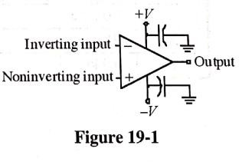

Procedure:

- From the specification sheet for the 741C op-amp (http://www.ti.com), determine the typical and maximum values for each quantity listed in Table 19-1. Record the specified values for 𝑇_{𝐴} = 25°C. Note the units that are listed on the right side of the specification sheet.

Table 19-1

Step | Parameter | Specified Value |  |  |  | Measured Value
 |  | Minimum | Typical |  | Maximum
2d | Input Offset  Voltage 𝑉_{𝑂𝑆} |  | 1 mV | 5 mV |  | 2.069 mV
3d | Input Bias Current, 𝐼_{𝐵𝐼𝐴𝑆} |  | 80 nA | 500 nA |  | 4.08
3e | Input Offset  Current, 𝐼_{𝑂𝑆} |  | 20 nA | 200 nA |  | 84.62 nA
4b | Differential Gain, 𝐴_{𝑣(𝑑)} |  |  |  |  | 1020 V/V
4c | Common-Mode Gain, 𝐴_{𝐶𝑀} |  |  |  |  | 0.1346
4d | CMMR` | 80 dB | 95 dB |  |  | 77.59 dB
5 | Slew Rate |  | 0.5 V/µs |  |  | 0.51 V/μs

- In this step you will measure the input offset voltage 𝑉_{𝑂𝑆}, of 741C op-amp. The input offset voltage is the amount of voltage that must be applied between the input terminals through two equal resistors to give zero output voltage. It is a dc parameter.

  - Measure and record the resistors listed in Table 19-2. 𝑅_{𝐶} is for bias compensation.

  - Connect the circuit shown in Figure 19-2. Install the 1µF bypass capacitor on the power supply leads as shown. Note the polarities of the capacitors.

  - Measure the output voltage 𝑉_{𝑂𝑈𝑇}. The input offset voltage is found by dividing the output

voltage by the closed loop gain. The close loop gain is: 𝐴_{𝑣(𝑐𝑙)}
= 𝑅𝑓 + 1 (assuming a
𝑅𝑖

noninverting amplifier for the purpose of the offset calculation).

  - Record the measured 𝑉_{𝑂𝑠} in Table 19-1.

Table 19-2
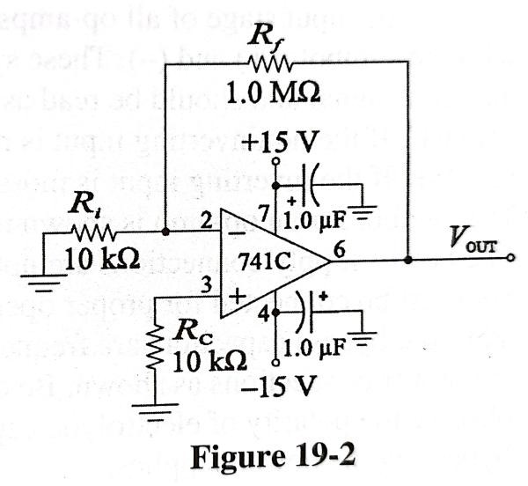
Resistor | Listed Value | Measured Value
𝑅_{𝑓} | 1MΩ | 1.002 MΩ
𝑅_{𝑖} | 10kΩ | 9.921 kΩ
𝑅_{𝑐} | 10kΩ | 9.921 kΩ

- In this step, you will measure the input bias current, 𝐼_{𝐵𝐼𝐴𝑆} and the input offset current, 𝐼_{𝑂𝑆} of a 741C op-amp. The input bias current is the average of the input currents at each input terminal. The input offset current is a measure of how well these two currents match. The input offset current is the difference in the two bias currents when the output voltage is 0V.

The input bias current and input offset current are dc parameters.

  - Measure and record the resistor listed in Table 19-3.

  - Connect the circuit shown in Figure 19-3.

  - Measure the voltage across 𝑅₁ and 𝑅₂ of Figure 19-3. Use Ohm’s law to calculate the current in each resistor.

  - Record the average of these two currents in Table 19-1 as the input bias current, 𝐼_{𝐵𝐼𝐴𝑆}.

  - Record the difference in these two currents in Table 19-1 as the input offset current, 𝐼_{𝑂𝑆}.

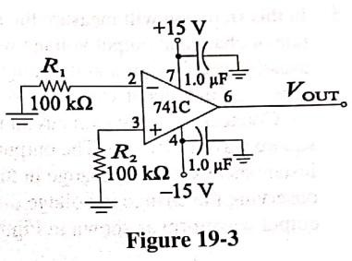
Table 19-3

Resistor | Listed Value | Measured Value
𝑅₁ | 100kΩ | 99.93 kΩ
𝑅₂ | 100kΩ | 98.8 kΩ

- In this step, you will measure the common-mode rejection ratio, CMRR, of a 741C op-amp. The basic CMRR is the ratio of the op-amp's differential gain (𝐴_{𝑣(𝑑)}) divided by the common- mode gain (𝐴_{𝑣(𝑐𝑚)}). Because it is a ratio of gains, CMRR is an ac parameter. It is frequently expressed in decibels (indicated with a prime symbol) according to the definition:
𝐶𝑀𝑅𝑅′ = 20 log 𝐴𝑣(𝑑)
𝐴𝑣(𝑐𝑚)

- Measure and record the resistors listed in Table 19-4. For an accurate measurement of CMRR’, resistors 𝑅_{𝐴} and 𝑅_{𝐵} should be closely matched as should 𝑅_{𝐶} and 𝑅_{𝐷}.

- It is more accurate to compute the differential gain 𝐴_{𝑣(𝑑)}, based on the resistance ratio than to measure it directly. Determine the differential gain by dividing the measured value of 𝑅_{𝐶} by
𝑅_{𝐴}. Enter the differential gain, 𝐴_{𝑣(𝑑)}, in Table 19-1.

- Connect the circuit shown in figure 19-4. Set the signal generator for 1 𝑉_{𝑝𝑝} at 1kHz. Measure the output voltage, 𝑉_{𝑜𝑢𝑡(𝑐𝑚)}. Determine the common-mode gain, 𝐴_{𝑣(𝑐𝑚)}, by dividing 𝑉_{𝑜𝑢𝑡(𝑐𝑚)} by 𝑉_{𝑖𝑛(𝑐𝑚)}. Record the result in Table 19-1.

- Determine the CMRR’, in decibels, for your 741C op-amp. Record the result in Table 19-1.

Table 19-4
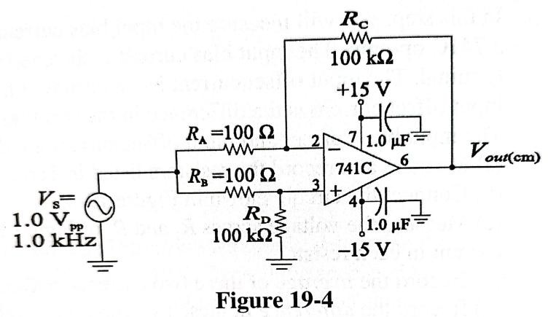
Resistor | Listed Value | Measured Value
𝑅_{𝐴} | 100Ω | 97.9 Ω
𝑅_{𝐵} | 100Ω | 98.08 Ω
𝑅_{𝑐} | 100 kΩ | 99.93 kΩ
𝑅_{𝐷} | 100 kΩ | 98.8 kΩ

- In this step, you will measure the slew rate of your op-amp. Slew rate is the internally limited rate of change in output voltage with a large-amplitude step function applied to the input. It is usually specified for a unity-gain voltage-follower with a fast-rising input pulse. It is usually expressed in units of volts/microsecond (V/µs).

Connect the unity gain circuit shown in Figure 19-5. Set the signal generator for a 10 𝑉_{𝑝𝑝} square wave at 10 kHz. The output voltage will be slew-rate limited and will not respond instantaneously to the change in the input voltage. The slew rate can be measured by observing the change in voltage divided by the change in time at any two points on the rising output waveform as shown in Figure 19-6.

Record the measured value in Table 19-1.

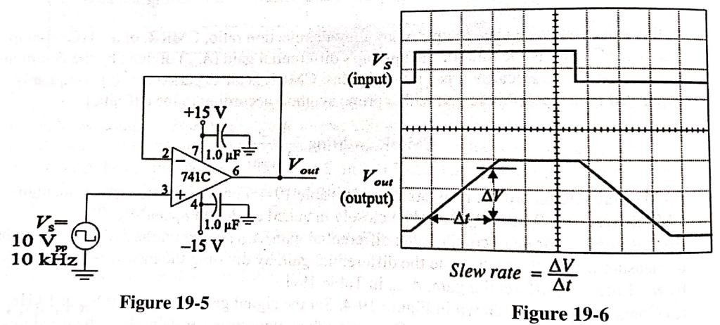

Conclusion:
Evaluation and review Questions:

- What is the meaning of the (+) and (-) terminals on the op-amp symbol?
Corresponden a las terminales de entrada del Op-amp, donde (+) indica que es la entrada no-inversora y (-) es la entrada inversora.

- Explain the meaning of input offset voltage.

- What is the difference between the input bias current and input offset current?

- (a) What is the difference between differential gain and common-mode gain?

  - Explain how you measured the CMRR’ of the 741C.

  - What is the advantage of a high CMRR?

- What is the advantage of fast slew rate for an op-amp?

For further investigation:

Although the output impedance of an op-amp is low, it does not follow that an op amp can drive a very small load impedance. Op-amps have a current-limiting circuit to protect the output when it is short circuited or when the load is too small.
Test the current limit of your op-amp using the voltage-follower circuit you constructed in step 5.
Reduce the input frequency until you observe no slew rate limiting on the output. While observing, connect a 10Ω resistor between the output and ground.
Sketch the input and output signals and determine the current limit for both the positive and negative excursion of the signal. Compare the measured current limit with the specified current limit.
For the signal observed, what is the smallest resistor you could use without having current limiting?

